With reference to specific examples explain why museums and exhibitions have become sites of cultural contest and discuss whether they can ever escape their colonial inheritance.

Museums first opened their doors to public scrutiny in the 19th Century. The public were at last able to gain a glimpse of cultures further afield, lands that were deemed accessible only to the wealthy explorers, whilst remaining close to home. Knowledge of more foreign lands, previously only gained through literary texts became accessible firsthand. However, for the indigenous communities involved, the situation was not quite so optimistic. The artefacts on display often shielded a turbulent history of colonialism and power whilst simultaneously presenting a false picture of these ‘distant’ cultures. It is issues such as these that remain problematic in the present day. Increased publicity in recent years has provided such indigenous communities with room to voice their objects to sites and artefacts of particular contest, yet is it enough to allow the colonial inheritance of exhibitions and artefacts to be forgotten? It is this that shall expanded upon in the course of this essay by way of a variety of examples, in order to assess whether any progress has been made in searching for a compromise within a twenty first century debate that remains deeply rooted to the past.

The problematic issues surrounding museums and exhibitions are embedded in the questionable way in which many of the cultural artefacts were collected during the colonial period. Whilst many were received as gifts, many were also acquired through less amiable terms such as as loot during military campaigns or by way of confiscation by European Missionaries intent on encouraging the spread of Christianity, even if this was at the cost of destructing indigenous communities (Simpson 1996, p.192). Indigenous communities were given little consideration. Instead, cultural artefacts were seen more as souvenirs, symbols of colonial success or as a “representation of ‘primitive people’” (Bennett, 1995 p.78) in contrast to the progressive Western societies. Indeed it is this which forms one of the core areas of contest.

Another area of contest lies in the ideologies of power that indigenous communities believe remain deeply embedded within many exhibitions since their day of opening, thus making it difficult for one to forget the colonial ancestry that is attached. Museums became not only ‘exhibitionary complexes’ (Bennett, 1995 p.60) but also educational complexes – a place where the public could learn of more ‘exotic’ cultures. Whilst this may be seen originally as a positive acquisition of knowledge, it also meant that the public was extremely impressionable and absorbed the pre-shaped vision of indigenous communities, rather than with a more objective approach. This often meant, or so the Foucauldian argument suggests, that the power relations embedded within many displays, were being inadvertently filtered into the visitors’ perspective of these ‘other’ communities (Bennett, 1995).

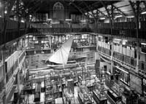
There are many sites of cultural contest, a somewhat early example being the Pitt Rivers Museum. The Pitt Rivers Museum (Figure 1) has faced much criticism, particularly in its grouping of artefacts. Artefacts were grouped Figure 1 together with those of similar usage rather than for context purposes in order to contrast varying artefacts against each other, with ancient archaeological finds grouped with “contemporary ethnographical materials”
(Lidchi, p.188) questionably suggesting man’s evolution. This somewhat presumes that some of the artefacts on display are from dying cultures, when more often than not, many are still in existence today. Many artefacts continue to have a role to play at the centre of many such cultures’ belief systems, for example, the Zuni ahayu:da is much more than an inanimate argument by the Zuni community but rather a living being with spiritual power (Simpson, 1996). However, unfortunately artefacts continue to be placed in a historic framework, presenting a particular period in the past, which can lead the visitor on a somewhat cautionary evolutionary trail.

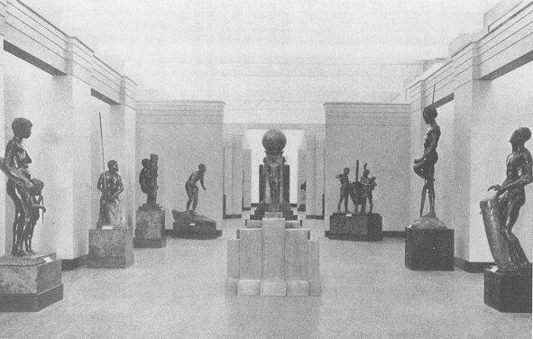
It is necessary to move away from this “West and the rest” (Hall, 1992) perspective, further distancing the indigenous communities as the ‘other’ as presented in many exhibitions. This can be seen in another exhibition of particular contest: the “Races of Mankind” exhibition in the Field Museum of National History. Here, 101 life-size bronze sculptures produced by Malvina Hoffman (Figure 2), each representing a human racial type were individually displayed, each hoping to represent a Figure 2 particular culture by presenting each sculpture in what was hoped to be
“an authentic moment of life”
(Teslow. 1998, p.64).
However, in actual fact, they were more stereotypical than authentic, with examples such as the Hawaiian surfer and African Warrior typifying this approach. Cultures were automatically presented as though stuck in the past by presenting an idealised perception of the past, rather than modern-day reality. A Western bias was also enforced, not only in the way in which Americans were more positively represented but also in the way in which the sculptures were arranged - with European and American races dominating the exhibition whilst Asian, African and Oceania races were presented in less prominent positions (Teslow, 1998). Museums such as these have led indigenous communities today to view them museum exhibitions with increased scepticism, as often an inaccurate perception of indigenous communities is presented.

A more recent site of relative contest is the Chase Manhattan Gallery of North America. While positive changes have been made, areas concerning the semiotics of the Native American display are still questionable. The ‘panel texts’ (Peers, 2000) attributed to each display case are very brief and are often somewhat confusing for the visitor due to the numbering system that has been put in place, thus often encouraging them to make their own assumptions. One particular artefact by way of example is the North-eastern Woodlands hide strip, which is inconspicuously displayed with very brief details. In actual fact, it is embedded in a history of persecution by European Settlers and extinction – something which the display fails to expand upon, thus providing little by way of context (Peers, 2000).

It is somewhat unsurprising then, that source communities have begun to contest against such sites and artefacts by requesting their repatriation. The repatriation debate is dichotomous in its impact upon indigenous communities. Primarily, by way of definition, the requests by indigenous communities for
“the return of objects to their country or culture of origin”
(Simpson, 1997; p.1)
only serves to emphatically remind indigenous communities of their colonial history, yet simultaneously, if successful in their request for repatriation, it can encourage communities to move forward and leave the past behind. It seems unlikely that the latter has been achieved completely as yet, but the increased publicity that repatriation has gained in recent years has only served to better the indigenous communities’ cause.

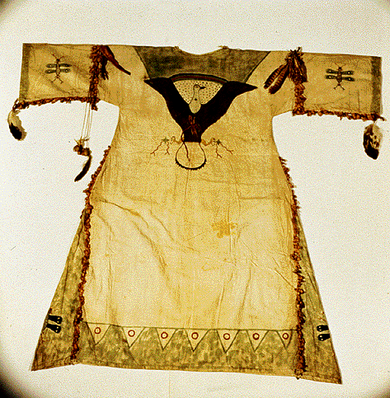
Whilst Britain is still yet to face the full impact of the repatriation debate, it has had such a great impact in America that it has given rise to the introduction of new legislation. Indigenous communities have been given an equal voice in order to influence how artefacts are presented and cared for, in order that a compromise is made. Increased political action has helped provide indigenous communities with a platform on which they can voice their objections and thus in time, has raised the public’s awareness. A prime example of this can Figure 3 be seen in the passing of the Native American Graves Protection and Repatriation Act in American in 1990 (Butler, 2001) thus allowing requests for repatriation to be truly heard and taken seriously. Indeed, there are many such requests for repatriation, an example of which is a Lakota Ghost Dance shirt (Figure 3) from the Kelvingrove Museum in Glasgow, which was requested for repatriation by the Wounded Knee Survivors Association. The Lakota people, in emphasising the continued cultural relevance that the shirt has today, presented a strong argument. Yet, whilst the artefact was granted return, certain conditions were put in place in order that the shirt may be returned to the museum on occasion, thus making it almost impossible for them to forget their colonial history (Harvey, 1998). This seems to suggest therefore whilst progress is being made, it is relatively slow as both the source communities and the museums role has to be considered. Whilst the return of artefacts would encourage native communities to leave their colonial past behind them, the museums need to be assured, by way of the conditions attached to many objects, they can mean the precious historical lessons that can be learnt from them shall not be lost.

Encouragingly, museums are being encouraged to work with indigenous communities in order to meet a compromise, as seen in the Portland Museum Of Art (Clifford, 1999) where discussions concerning the Northwest Coast Indian Collection involved group of Tlingit Elders as representatives at the meeting. Clifford suggests that museums should now be seen as “contact zones” where such separated communities can re-establish ongoing relations and erase any past discrepancies. It seems both the West and indigenous communities are more willing to forget their colonial past in order to have a more equal and joined-up future.

In conclusion, it seems as though a shift in power is occurring as indigenous communities have gained increased access in order to influence how objects which often signify much more than an object of beauty, are exhibited. Museums have begun to realise that the colonial ancestry intrinsically attached to many cultural artefacts cannot be ignored as source communities have a right to influence the future exhibition of particular artefacts, as well as the representation of ‘other’ cultures more generally. Entrance to museum committees and the increased publicity that surrounds the repatriation debate has encouraged this process, however much more is still yet to be done, especially in Britain. Britain needs to follow in America’s footsteps in order to make the significant legislation changes, as whilst compromise has been met on some exhibitions, it is somewhat of an uphill struggle for many source communities before many moves towards repatriation are in motion, making it increasingly difficult to escape their colonial inheritance.

REFERENCES

Bennett, T (1995) “The Birth of the Museum”, ‘The Exhibitionary Complex’, Ch. 2. Pp. 59-88. Routledge. London.

Butler, T (2001) ‘Body of Evidence’. Museums Journal. August 2001. Vol. 100, No. 8 pp. 24-27.

Clifford, J (1999) ‘Museums as contact zones’, ch. 21 pp. 435 – 457 in D. Boswell & J. Evans (eds) (1999) “Representing the Nation: A Reader”. London. Routlege.

Hall, S (1992) ‘The West and the Rest: Discourse and Power” in S Hall, and B Gieben (1992) (eds) “Formations of Modernity.” Cambridge. Open University Press/Polity Press as cited in H. Lidchi in ‘The Poetics and the Politics of Exhibiting Other Cultures” Ch.3. pp.151-208 in Hall (1997) “Representation – Cultural Representations and Signifying Practices.” London. Sage.

Harvey, S (1998) ‘Glasgow says yes – this time’. Museums Journal. December 1998. Vol. 98, No. 12. Museums Association.

Lidchi, H (1997) ‘The Poetics and the Politics of Exhibiting Other Cultures” Ch.3. pp.151-208 in Hall (1997) “Representation – Cultural Representations and Signifying Practices.” London. Sage.

Simpson, M. G. (1996) ‘Cultural artefacts – A question of Ownership.’ Ch.8 pp.191-214. in “Making Representations – Museums in the Post-Colonial Era.” Routledge. London.

Simpson, M (1997) ‘To have and to hold’. Museums Journal. October 1997, Vol. 97, No. 10, pp.29-30.

Teslow, T. L (1998) ‘Reifying race – science and art in “Races of Mankind” at the Field Museum of National History’, Ch. 4, pp.53-76 in S. Macdonald (ed) (1988) “The Politics of Display”. Routledge. London.

ILLUSTRATIONS

Figure 1: Picture of Pitt Rivers Museum
‘Pitt Rivers Museum’, as cited on http://www.prm.ox.ac.uk/
as accessed on 17/01/03

Figure 2: Picture of Malvina Hoffman’s Exhibition “Races of Mankind”.
‘Malvina Hoffmann Remembered’ as cited on http://www.hampton.lib.nh.us/hampton/history/vignettes/malvinahoffman.htm
as accessed on 17/01/03

Figure 3: Picture of ghost dance shirt:
‘The West’ as cited on http://www.pbs.org/weta/thewest/resources/archives/eight/68_07.htm
as accessed on 14/01/03.

Web address for belts:
http://tuscaroras.com/jtlc/Wampum/sacred_wampum_1.html
as accessed on 14/01/03

people in belt pic: Iroquois Confederacy Chief's Bernie Parker, Arnie General, Allan MacNaughton, Jake Thomas, Harvey Longboat

A successful example of this can be seen by way of the Woodland Cultural Centre in Ontario which promotes the collaberation of Museums and native communities and has moved away from the ‘them and us’ approach (John di Folco, April 1995, ‘Native Lessons’, Museums Journal). It also places the indigenous communities in the present, instead of presenting them as a dying culture, stuck in the past.

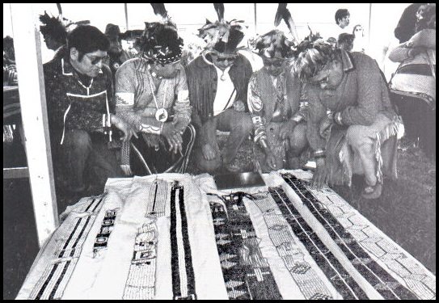
Another prominent example is that of the Wampum belts in the New York State Museum. These belts were, and indeed continue to be, highly significant to the traditional Iroquois people as each represents significant tribal events such as treaties and agreements. Whilst their request for repatriation was successful, it was over ninety years before the belts that were once held in the New York State Museum were repatriated back to the original source communities. This seems to suggest therefore whilst progress is being made, it is realtively slow as both the source communities and the museums role has to be considered. Whilst the return of artefacts would encourage native communities to leave their colonial past behind them, the museums need to be assured, by way of the conditions attached to many objects, they can mean the precious historical lessons that can be learnt from them shall not be lost.

